Consider that for every element list[i], its left child is list[2*i], its right child is list[2*i+1] and its parent is list[i/2].
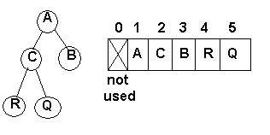
list[2] holds the C. Its left kid is list[2*2] == list[4] which holds R,
its right kid is list[2*2+1] == list [5] which holds Q
and its parent is list[2/2] == list[1] which is A.

Attached is a shell for an animal guessing game, with accompanying helper methods. Write a program that will ask the user a series of yes and no questions, attempting to guess the animal that they are thinking of. *If the program does not know the animal, it will prompt the user to enter the animal name and an accompanying question so it will be a bit smarter the next time it is run. The database will be read in from a file when the program starts, and if anything is added, the file will be re-written with the new item.

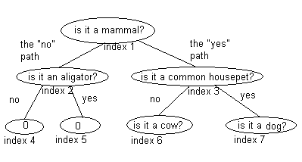
These elements will be stored in an array in level order. Traversing through the array will end when you follow a path to a cell that contains a “0” String, or an index that is out of the bounds of the array itself. Index 0 is not used.

* In the situation in which the program does not know the animal that you are thinking of, you need to carefully consider how the array should be updated. Rather than always adding a new level to the array, find a way of replacing some of the existing elements such that the size of the array is minimized.

